Assignment No 8
1. Write a query that uses a subquery to obtain all orders for the customer named Cisneros. Assume you do not know his customer number (cnum).
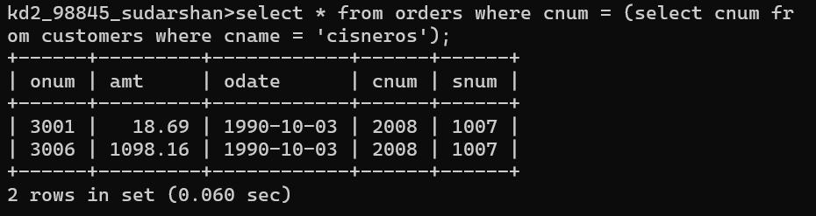

2. Write a query to display the order amount, customer names and ratings of all customers where the amount is greater than the average amount from the orders table.
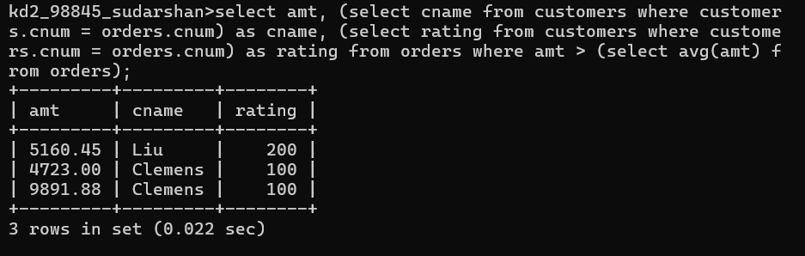

3. Write a query that selects the total amount in orders for each salesperson for whom this total is greater than the amount of the largest order in the table.
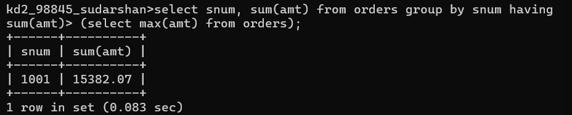

4. Write a query that selects all customers whose ratings are equal to or greater than ANY of Serres’. (Hint: find all customers of serres salesperson).
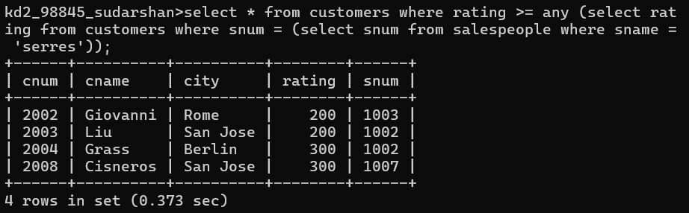

5. Write a query that will find all salespeople who have no customers located in their city. (Hint: Choose the correct keyword ANY/ALL).
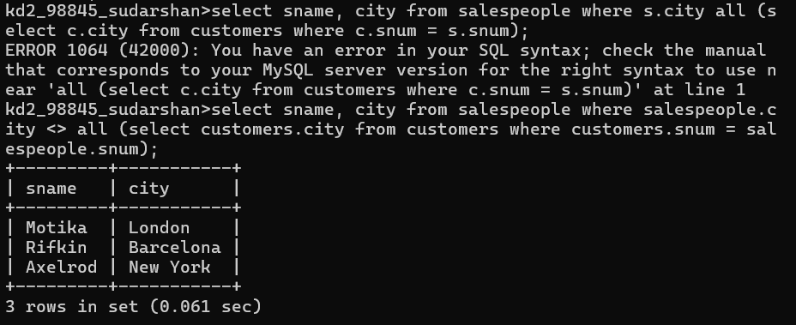

6. Write a query that selects all orders for amounts greater than any for the customers in London.
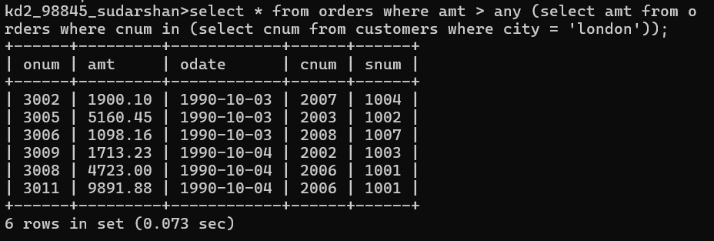
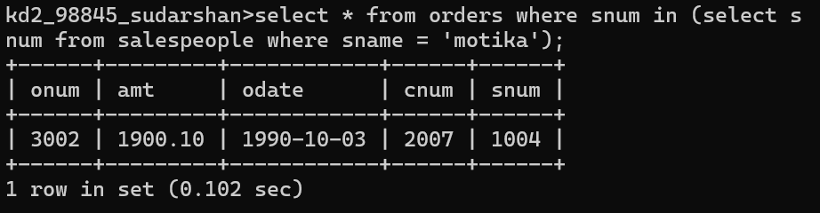
7. Extract all the orders of Motika.

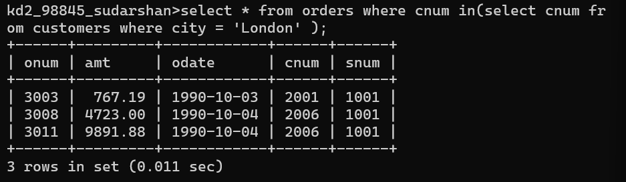
8. Find all the orders of salespeople servicing customers in London.

9. Find names and numbers of all salesperson who have more than one customer.
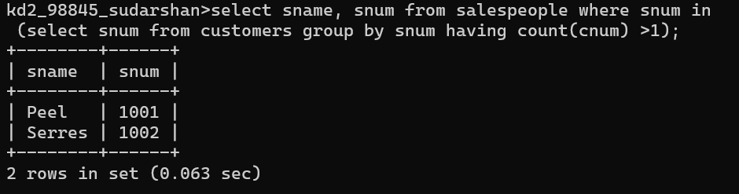

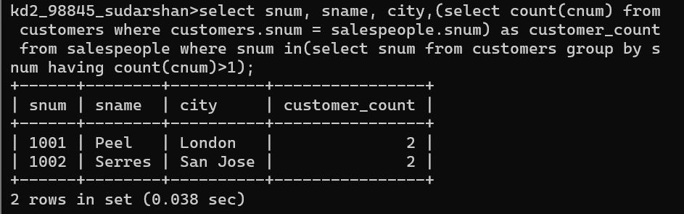
10. Find salespeople number, name and city who have multiple customers. Display the count of customers as well.
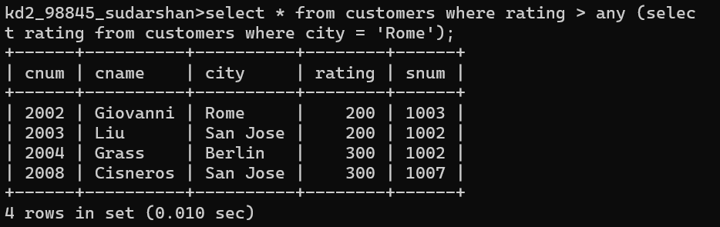
11. Select customers who have a greater rating than any other customer in Rome.

12. Select all orders that had amounts that were greater that at least one of the orders from ‘1990-10-04’.
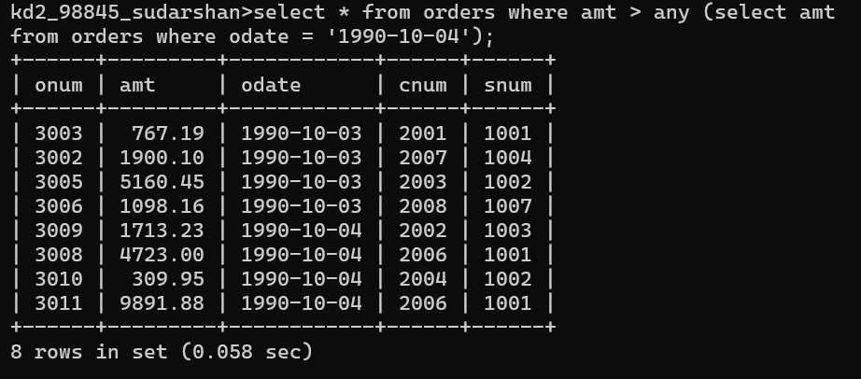

13. Find all orders with amounts smaller than any amount for a customer in San Jose.
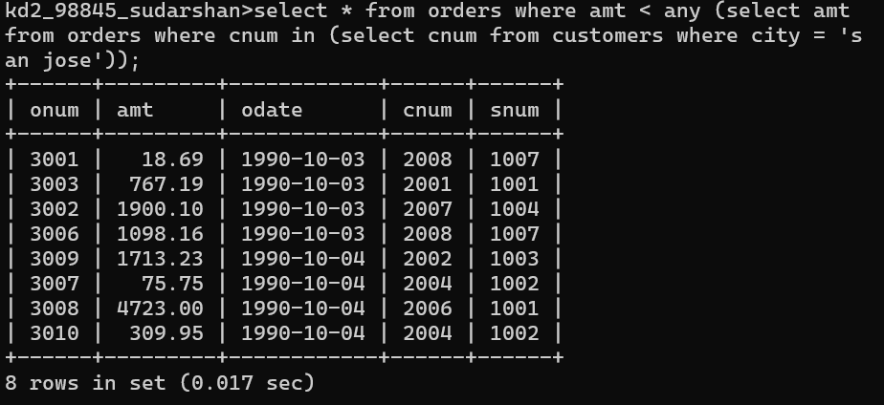
14. Select those customers whose rating are higher than every customer in London.
